ID 2209 - Distributed Artificial Intelligence and Intelligent Agents

Assignment 2 - Negotiation and Communication (FIPA)

Group 3

Albert Asratyan

Justas Dautaras

15.11.2019

In this assignment, we were tasked with creating an auction bidding simulation in GAMA, and implement the functionalities that emulate real world people in auctions where a person can get make a bid if the price of an item that is being sold does not exceed the available funds of the person. The auction is using the Dutch auction scheme, where the price decreases if noone is willing to make a bid. If the price reaches a certain minimum, the auction is cancelled.

**How to run**

Run GAMA 1.8 and open *Main.gaml* file. Press the green button ‘my_experiment’ to run the simulation.

**Species**

**Agent People**

This agent has the following behaviour patterns: beIdle (wander around while waiting for the auction to proceed), receive_informs_from_auctioneer (the agent gets contacted by the auctioneer and replies whether it wants to be a part of the auction or no, in the base version of the assignment, it always replies positively), receive_requests_from_initiator (the agent gets contacted by the auctioneer with the new price of the item if the agent has previously answered positively to the inform request). Has a variable that is generated randomly and contains the maximum price that the agent is willing to pay.

**Agent Auctioneer**

This agent is responsible for contacting the “people” agents and informing them about the auction start or the new prices for the goods. If the price reaches a certain point and the item has not been bought yet, the auctioneer cancels the auction.

**Implementation**

We began this task by watching a tutorial on youtube and then continued with other tutorials and documentation from their site. First of all, we created the necessary species - people, information stand, water stand and food court. Then we assigned attributed to them, such as location, hunger, thirst. And finally, we developed the logic so that hunger and thirst would decrease and then the agents would find their ways to fill it up again.

We began this task by using the core of the previous homework’s implementation in order to build a skeleton for this homework. We have then proceeded by implementing a basic FIPA communication, starting with start_conversation and inform and cfp as performatives. After that, we have implemented the people agents’ responses to the auctioneer.

**Results**

To demonstrate that we successfully accomplished the task we made the agents write to the terminal. When an agent makes a bid, a corresponding message is prompted.

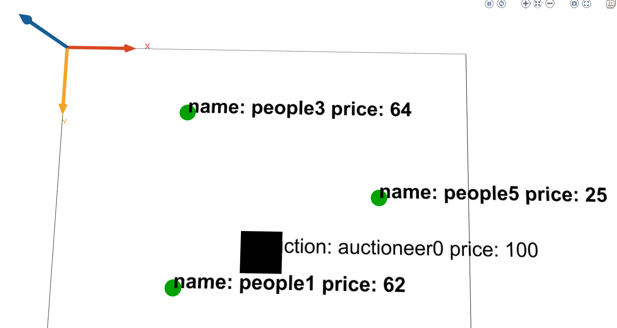

*Figure 1: A screenshot of the final solution + creative part.*

**Challenge 1**

To complete the first challenge we had to implement multiple auctions with different items at the same time. The way this works is in the following way:

* An auction starts with each auction offering different items.
* A person gets an invitation from an auction, specifying what they are selling.
* If the person is interested in an item, he joins the auction.
* Auction starts with the highest price and keeps lowering it until at least one proposal arrives and then it is sold to the first one.
* If it reached the minimum value, the auction ends without the item being sold to anyone.

**Challenge 2**

To complete the second challenge we added an English auction type, as well as Sealed bid type auction.

English auction:

* Bid start from the lowest price.
* Price keeps increasing until there is either a single bidder left or none.
* If there is none left, we keep track of the last bidder and he wins.

Sealed bid auction:

* Auction send a notification about auction starting.
* Bidders reply with their price.
* Auction announces a winner.

**Creative implementation**

For our creative solution, we added an attribute to people that they might be fake buyers (a fake buyer doesn’t actually buy the item, just bids). In case the auctions catches a fake bidder, the bidder is removed from the auction. Each person has a 50% chance to be a fake bidder. Also, when a person wins an auction, it starts dancing in a circle with animations behind him.

We argue that we should receive a bonus point for creativity in this assignment because not only did we include functionality other than what was asked in the assignment (3d gui, GUI improvements, math functions), but it is also an interesting visually presentable feature.

|  |  |
| --- | --- |
| *Qualitative/Quantitative questions* | *Answer* |
| Time spent on finding and developing the creative part | 2 hours |
| In what area is your idea mostly related to... | 3D GUI, GUI improvements, math functions |
| On the scale of 1-5, how much did the extra feature add to the assignment? | 4 |
| On the scale of 1-5, how much did you learn from implementing your feature? | 5 |

**Discussion / Conclusion**

All in all, the assignment has taught us how basic fipa skill interaction works in GAMA and is a solid foundation for whatever challenge comes next.